CIS1513 Midterm Project Order Application 2015
STEP 1: Done Creating HR ERD/Tables: Employees, Jobs, Depts, Agencies
EMPLOYEE
#Employee ID
*First name
*Last Name
*Email
*address
*phone
*birthdate
*jobid (FK)
*Hiredate
*Manager ID(fk)
Dept id (fk)
*EMP_TYPE -add to help with subtypes

NOTES:
An employee is either salary or Hourly and if they are houly we need an Agency_ID

If an hourly employee works over 40 hours in a week, overtime will be calculated.

Emps will not receive holiday pay unless they have worked over 6 months.

JOB
#JOBID
*JOBTITLE
*MIN_SAL
*MAX_SAL

DEPARTMENTS
#DEPARTMENT ID
*DEPARTMENT NAME
o BUDGET AMT

AGENCY
#Agency_Id
*Name
*contact
*email
*phone
SALARY-just a label
*Yearly_Salary

HOURLY-just a label
*Hourly_rate
*Agency_ID

STEP 2 Resolving a MANY to MANY
ORDERS/PRODUCTS:
An Order must have one and only one product. A Product may be in many Orders.
That means that our customers will have to place an order for every product they purchase.
WRONG: Then WE are NOT going to have any CUSTOMERS!! - it really is a many to many that we need to resolve.
Cust_ORDERS
#ORDER_ID

PRODUCTS
#Product_ID
NOTES:
Customer Credit Limit must be less than 1000.

Products must come from authorized Manufacturers.

Customers intial Credit limit is set to 0 unless a Credit Check has been processed.

CORRECT the Many to Many: An Order can have many products.
Many Products can be in many Orders.
CUST_ORDERS
#ORDER_ID

PRODUCTS
#Product_ID

How to we resolve this??? (Intersection Entity)____________________________
CUST_ORDERS
#ORDER_ID

CUST_ORDER_ITEMS
#Product_ID
#ORDER_ID
*Qty
PRODUCTS
#Product_ID

Someone on yr team has put together all Entities/Attributes. You need to connect all related entities with relationship lines
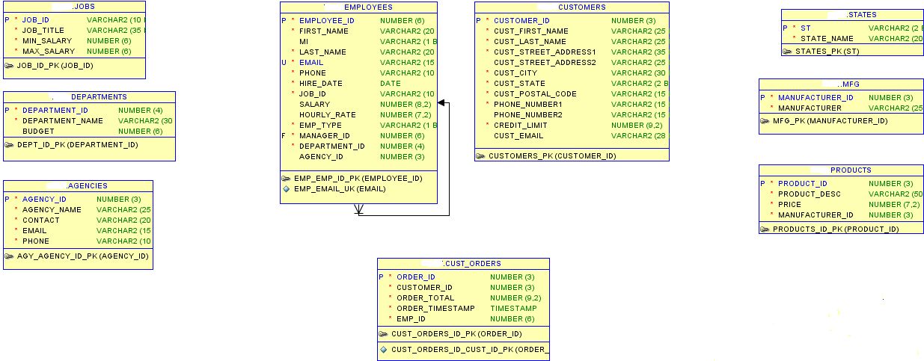
CUST_ORDER_ITEMS
#ORDER_ID(PK,FK)
#Product_ID(PK,FK)
*Qty Number(4)

PART 4 DON’T NEED TO DO.

PART 5 Business Rules Identified- add 4 Procedural Rules (Section 4 Lesson 2)

RULE Identified | Entity Affected
Procedural – Holiday Pay will only be paid after 6 months of tenure | Employees (Hourly Rate)
Procedural – Overtime given over 40 hours | Employees (Hourly Rate)
Procedural – Credit limit must be less than 1000 | Customers (Credit Limit)
Procedural – Customers credit limit is set to 0 unless a credit check is performed | Customers (Credit Limit)

PART 6 Building Physical Tables from ERD above.

The following tables will be built from spreadsheets. Import fr. I drive:

- Manufacturers

- States

- Products

- Customers

STEPS to IMPORT spreadsheets:
- Download zipped file to your H:\ or thumb drive

Go into SQLDEV click on TABLES and RIGHT mouse & choose IMPORT data.
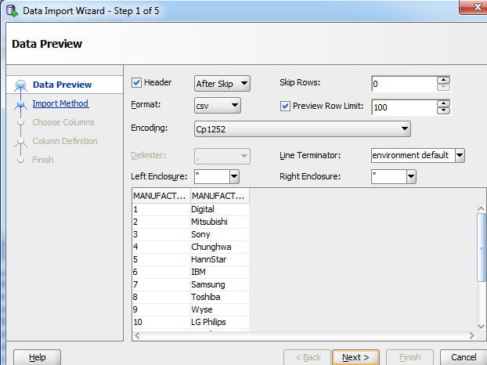
Find where the .csv files is that you unzipped.
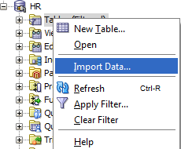

Follow the import wizard and all the steps.
Make sure the datatypes and lengths are correct from the ERD design.
IMPORT wizard makes all columns CHAR, but NOT all fields are CHAR!

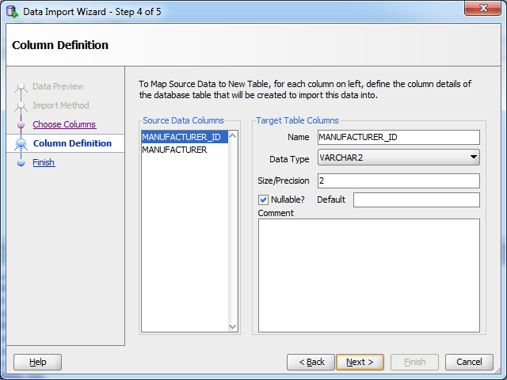
When completed, you will have a NEW table & it will be populated.

- PART 7 USING the PENCIL (alter table) to Fix the 4 tables imported thru spreadsheets. One table at a time, we will start with STATES.

We need to Add PK’s, FK’s and NOT Nulls.
Directions:
Click on the STATES table after you have imported it. The table should show up on the RIGHT side, Click on COLUMNS, then Click on the Pencil which is EDIT.

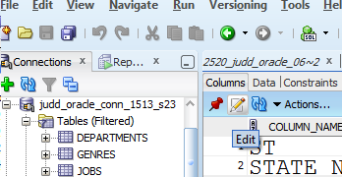

You will then see this window, Check your Diagram and see what columns are required, you will have to click on the Cannot be Null for each field that is required.

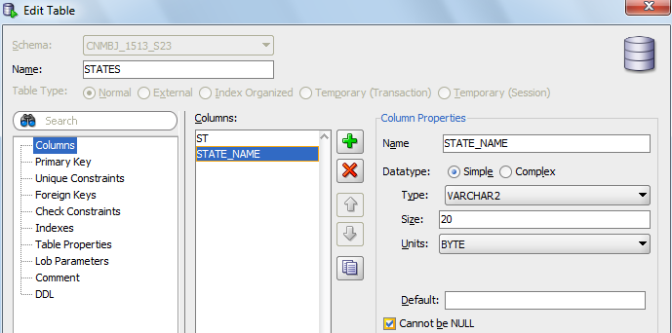

PART 7 Continued:

Then we will add the PRIMARY Key for STATES.
Click on Primary Key on the 1st column – then use the arrow key to move the column who will be the PK to the 2nd COLUMN (Selected columns)

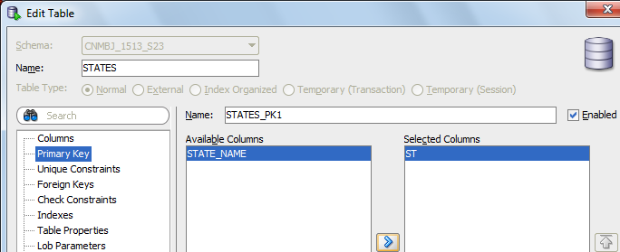

Now you need to go back & set PK, FK’s & NOT NULLS for the other tables: (Manufacturers, Products and Customers)

PART 8 Building Physical Tables using SQL code

The following tables will be built from SQL Code:
- Cust_Orders
- Cust_Order_Items

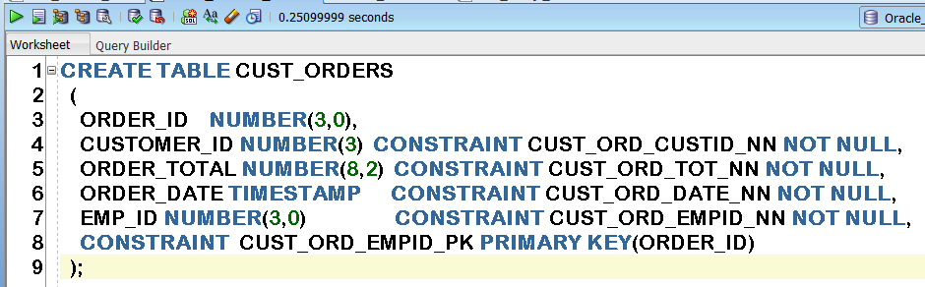

PART 9 Adding Data to your tables – from spreadsheets.
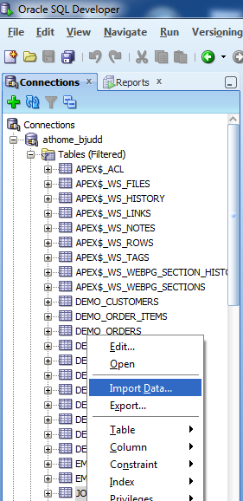
NOTE: If you have dates, you need to go into the csv file and reformat the dates into oracle date format dd-mon-yy. Click on column Right mouse, choose Format , date,

Go into SQLDEV click on table whose getting the data & choose IMPORT data. Find where yr. files are.

Follow the import wizard and all the steps.
When completed, your table will be populated with data.

PART 10 – Turning in your midterm project.
Congratulations you are almost finished Upload your document into BLACKBOARD with the following info:

Items to turn in for your midterm project in a word document named:

Lastname_1513_sec21_Midterm.doc

- Completed ERD diagrams – Relational (yellow) Logical (blue)
Use DATA MODELER. (directions at the bottom of this doc)

2. Screen Print of SQL tab (code) for the following tables only:

- Cust_Orders
- Cust_Order_Items
- Customers

NOTE: Directions on how to open Data Modeler.
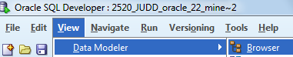

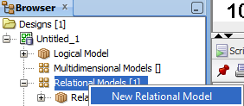
You should get a new window that opens,
Drop tables from your connection into Relational Window. You can rearrange the tables on the screen.
